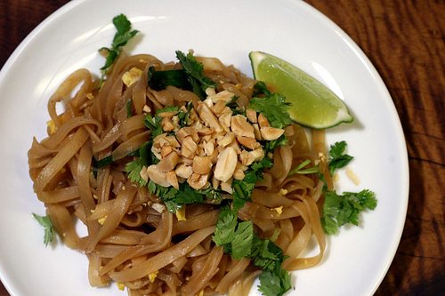

**Easy Pad Thai**

(adapted from Everyday Food)

*Serves 4*

8 ounces dried, wide and flat rice noodles  
2 tablespoons brown sugar  
2 tablespoons fresh lime juice, plus wedges for serving  
3 tablespoons soy sauce  
1 squirt (about 1/8 teaspoon) Sriracha (optional)  
2 teaspoons vegetable oil  
3 scallions (green onions), white and green parts, separated and thinly sliced  
1 garlic clove, minced  
2 large eggs, light beaten (optional)  
1/2 cup fresh cilantro  
1/4 cup chopped roasted, salted peanuts

1. Soak noodles according to package instructions. Drain.
2. In a small bowl, whisk together brown sugar, lime juice, soy sauce, and Sriracha.
3. In a large nonstick skillet, heat oil over medium-high heat.
4. Add scallion whites and garlic and cook, stirring constantly, until fragrant (about 30 seconds). Add eggs and cook, scraping skillet with spatula until eggs are almost set (about 30 seconds). Transfer eggs to a plate.
5. Add noodles, scallion greens, and sauce to skillet. Cook, tossing constantly, until noodles are soft (about 1 minute). Add egg mixture and toss to coat, breaking eggs up gently.
6. Serve noodles with lime wedges, topped with cilantro and peanuts.

**Notes and variations**

* Per serving: 315 calories, 7g fat (0.9g saturated fat), 3.6g protein, 60.5g carb, 1.4g fiber
* Per serving: $1.50 or less.
* As long as you use a gluten-free soy sauce, this is a gluten-free recipe.
* Vegetarian, even. Skip the eggs for vegan.
* If you’re a carnivore try this: While the noodles are soaking, cut up 1 small chicken breast (or half of one of the colossal ones) into bite sized pieces. Marinate the chicken in a little bit of soy sauce and garlic (or make a little extra of the sauce for the noodles and marinate the chicken in that). *OR:* use shrimp (marinate same as chicken)… heck, use both. Cook them before you add the noodles to the pan.
* Leftovers: heat in the microwave or toss in a hot skillet for a minute to warm the noodles. Not *as* good as the first day but with a little extra lime juice, it makes a nice leftover-lunch.